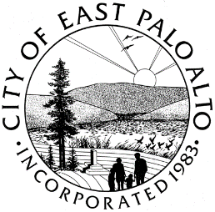

**CITY OF EAST PALO ALTO, CALIFORNIA**

**DEPARTMENT OF PUBLIC WORKS – ENGINEERING DIVISION**

**ADDENDUM 4**

**ADDISON AVENUE SAFE ROUTE TO SCHOOL AND GREEN STREET IMPROVEMENTS PROJECT – 22**

**CIP-ST-26**

Date: 3/17/2022

General Information

1. The bid schedule has been revised. Please see Addendum 4 Attachments A & B for the revised bid schedule and well as the redline version of the original bid schedule.
2. Plan sheet 3,5, and 6 has been revised. Please see Addendum 4 Attachment C.
3. Please see Addendum 4 Attachment D for preliminary geotechnical design information.
4. Please see Addendum 4 Attachment E for the revised technical specifications. Replace the original technical specifications with the revised technical specifications.
5. The last day for questions is now end of day Monday March 21st, 2022.

Batool Zaro

Batool Zaro

Assistant Engineer

City of East Palo Alto

**ADDENDUM No.4, ACKNOWLEDGMENT**

(To be submitted with the General Construction Contract, Attachment A of RFB)

REQUEST FOR BID – **ADDISON AVENUE SAFE ROUTE TO SCHOOL AND GREEN STREET IMPROVEMENTS PROJECT – 22**

City Project: **CIP-ST-26**

Bidder acknowledges receipt of this addendum, which shall be attached to the bid. Acknowledgement of receipt of this addendum is required in the space provided below. Failure to acknowledge the addendum may subject the bidder to disqualification.

I, , representing have carefully read this addendum, understand it, acknowledge receipt of it and will comply with its terms.

CONTRACTOR SIGNATURE DATE