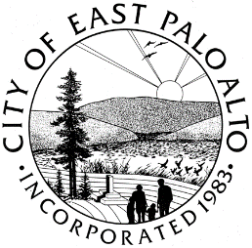

**CITY OF EAST PALO ALTO, CALIFORNIA**

**DEPARTMENT OF PUBLIC WORKS – ENGINEERING DIVISION**

**ADDENDUM 2**

**ADDISON AVENUE SAFE ROUTE TO SCHOOL AND GREEN STREET IMPROVEMENTS PROJECT – 22**

**CIP-ST-26**

Date: 3/4/2022

General Information

1. The Addison Avenue Project bid opening is rescheduled from March 8th, 2022, at 2pm to March 17th, 2022, at 2pm. The Zoom Meeting ID has remained the same (Meeting ID: 840 2731 3853).
2. All questions must be received by end of day March 10th, 2022. Questions may be emailed to Glen March at [gmarch@cityofepa.org](mailto:gmarch@cityofepa.org) .

Batool Zaro

Batool Zaro

Assistant Engineer

City of East Palo Alto

**ADDENDUM No.2, ACKNOWLEDGMENT**

(To be submitted with the General Construction Contract, Attachment A of RFB)

REQUEST FOR BID – **ADDISON AVENUE SAFE ROUTE TO SCHOOL AND GREEN STREET IMPROVEMENTS PROJECT – 22**

City Project: **CIP-ST-26**

Bidder acknowledges receipt of this addendum, which shall be attached to the bid. Acknowledgement of receipt of this addendum is required in the space provided below. Failure to acknowledge the addendum may subject the bidder to disqualification.

I, , representing have carefully read this addendum, understand it, acknowledge receipt of it and will comply with its terms.

CONTRACTOR SIGNATURE DATE