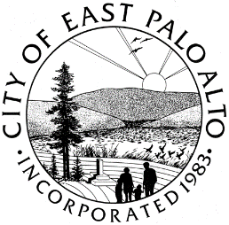

**CITY OF EAST PALO ALTO, CALIFORNIA**

**DEPARTMENT OF PUBLIC WORKS – ENGINEERING DIVISION**

**ADDENDUM 1**

**ADDISON AVENUE SAFE ROUTE TO SCHOOL AND GREEN STREET IMPROVEMENTS PROJECT – 22**

**CIP-ST-26**

General Information

* [Attachment E – “Addison Avenue Safe Route to School and Green Streets Improvements Project - Plans](https://www.cityofepa.org/sites/default/files/fileattachments/public_works/page/21168/attachment_e_-_plans_02112022.pdf)” has been replaced in its entirety. Refer to the updated plans on the City website.

Batool Zaro

Batool Zaro

Assistant Engineer

City of East Palo Alto

**ADDENDUM No.1, ACKNOWLEDGMENT**

(To be submitted with the General Construction Contract, Attachment A of RFB)

REQUEST FOR BID – **ADDISON AVENUE SAFE ROUTE TO SCHOOL AND GREEN STREET IMPROVEMENTS PROJECT – 22**

City Project: **CIP-ST-26**

Bidder acknowledges receipt of this addendum, which shall be attached to the bid. Acknowledgement of receipt of this addendum is required in the space provided below. Failure to acknowledge the addendum may subject the bidder to disqualification.

I, , representing have carefully read this addendum, understand it, acknowledge receipt of it and will comply with its terms.

CONTRACTOR SIGNATURE DATE