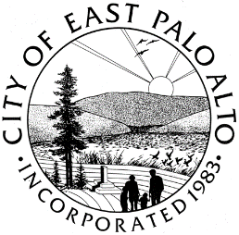

**CITY OF EAST PALO ALTO, CALIFORNIA**

**DEPARTMENT OF PUBLIC WORKS – ENGINEERING DIVISION**

**ADDENDUM 1**

**SENIOR CENTER ROOF REPAIR– 21**

**CIP-FA-04**

General Information

* Site visits may be scheduled on an individual basis till January 22nd, 2021. For scheduling site visits, please email Ms. Azalea Renfield "[arenfield@cityofepa.org](mailto:arenfield@cityofepa.org)"

Batool Zaro

Batool Zaro

Assistant Engineer

City of East Palo Alto

**ADDENDUM No.1, ACKNOWLEDGMENT**

(To be submitted with the General Construction Contract, Attachment A of RFB)

REQUEST FOR BID – **SENIOR CENTER ROOF REPAIR– 21**

City Project: **CIP-FA-04**

Bidder acknowledges receipt of this addendum, which shall be attached to the bid. Acknowledgement of receipt of this addendum is required in the space provided below. Failure to acknowledge the addendum may subject the bidder to disqualification.

I, , representing have carefully read this addendum, understand it, acknowledge receipt of it and will comply with its terms.

CONTRACTOR SIGNATURE DATE